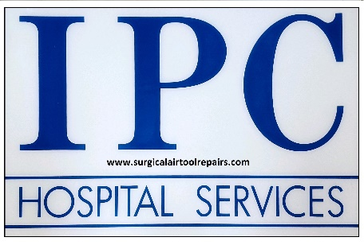
IPC Hospital & Veterinary Services Repair form

• Please include this form with the product you're sending us and fill out any added information.
• When your items arrive, we will do a thorough inspection and test on them, if you need a quote we will be in contact with you. Once we get the go-ahead from you, we will get the work done within 3-5 working days. We make every effort to return your item in this time frame. If in any event it is likely to take longer, we will be in contact.
: You can print this Services Repair form off to help you send your product.
Date
Name or practice

Contact Name
Contact Number
Contact Email
Return Address
Invoice Address (if different from above)
Product Name & Serial No
Description of Fault/Error
Post the items to
IPC Hospital Services Unit 1 Parkside Centre Potters Way Temple Farm Industrial Estate Southend on Sea Essex SS2 5SJ info@surgicalairtoolrepairs.com Office: 01702 965245

